1. Introduction to the Activities in 2009

Background

Our Åbo Akademi Process Chemistry Centre (PCC) was formed in 1998 by joining four research groups at the Faculty of Chemical Engineering at Åbo Akademi into one research centre with common objectives and research strategy. The PCC is a unique combination of chemistry, chemical technology and chemical engineering.

The PCC has successively grown in quantity and quality. Today we publish over 100 peer-review journal articles per year in leading journals of chemical engineering and chemistry, the total number of PhD theses finished during the last five years (2005-2009) has been 40. We have been visible in the international scientific arena; taking part in conferences and symposia, organizing scientific events, holding positions of trust in scientific journals and organizations, taking part in the scientific discussion in society. We have worldwide scientific collaboration and extensive industrial contacts.

Several prestigious prizes and nominations have come to the members of the PCC. Bjarne Holmbom received the Finnish Science Prize 2005 and the Wallenberg prize 2008, Mikko Hupa received the Fortum Foundation Prize in 2005, Ari Ivaska has been Research Professor at the Åbo Akademi Foundation and Tapio Salmi was appointed Academy Professor by the Academy of Finland for the period 2009-2013.

During the years, a new generation of scientists has grown up at the PCC, achieving high positions in industry and academia. Carita Kvarnström became Professor at the University of Turku; Jyri-Pekka Mikkola received the Incentive Award 2006 by Academy of Finland and became Professor at the University of Umeå. Johan Bobacka, Stefan Willför and Johan Wärnå are new young professors at the PCC. The PCC is the cradle of new science and new scientists and wants to progress towards future challenges.

A huge challenge for mankind is to shift the current technology, mainly based on fossil sources, to novel technologies based on renewable sources, such as the extensive and refined utilization of biomass. A real progress in this task requires close collaboration and interaction between researchers in chemistry and chemical engineering. The research teams forming the PCC at Åbo Akademi University have the competence in analytical chemistry, wood chemistry, combustion and materials chemistry, kinetics, catalysis and chemical reaction engineering. Our approach to understand the world and to solve the problems of the future we call Molecular Process Technology, which implies the development of new technological solutions based on a deep-going understanding of the chemical reactions and physical processes on the molecular level.

The Year 2009 in Numbers

The year 2009 was the fifth year of our second six-year period (2006-2011) as a National Centre of Excellence in research appointed by the Academy of Finland. In 2009 altogether 30 senior researchers and 50 PhD candidates worked in the 55 major research projects of the Centre. In addition, a number of shorter term visitors, Master’s students and support personnel participated in our activities.

Economically, the year 2009 was very good. The overall funding to the activities of the Centre was higher than in any previous years since the founding of the Centre.

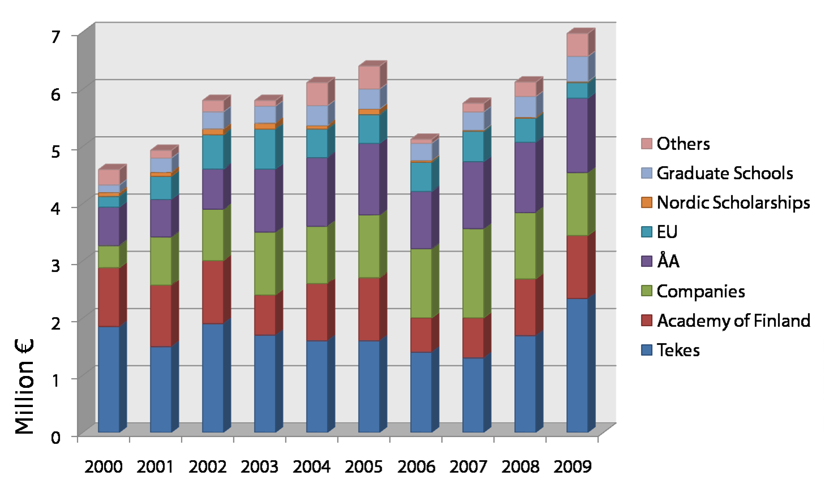
The funding of the Åbo Akademi Process Chemistry Centre 2000-2009

From an academic point of view the year 2009 was also very productive. The table below gives the key numbers. Our research resulted in altogether 118 papers in scientific publication series with the full referee system, and more than 200 other publications, reports and articles. Seven doctoral theses and 17 masters’ theses were finished in 2009.

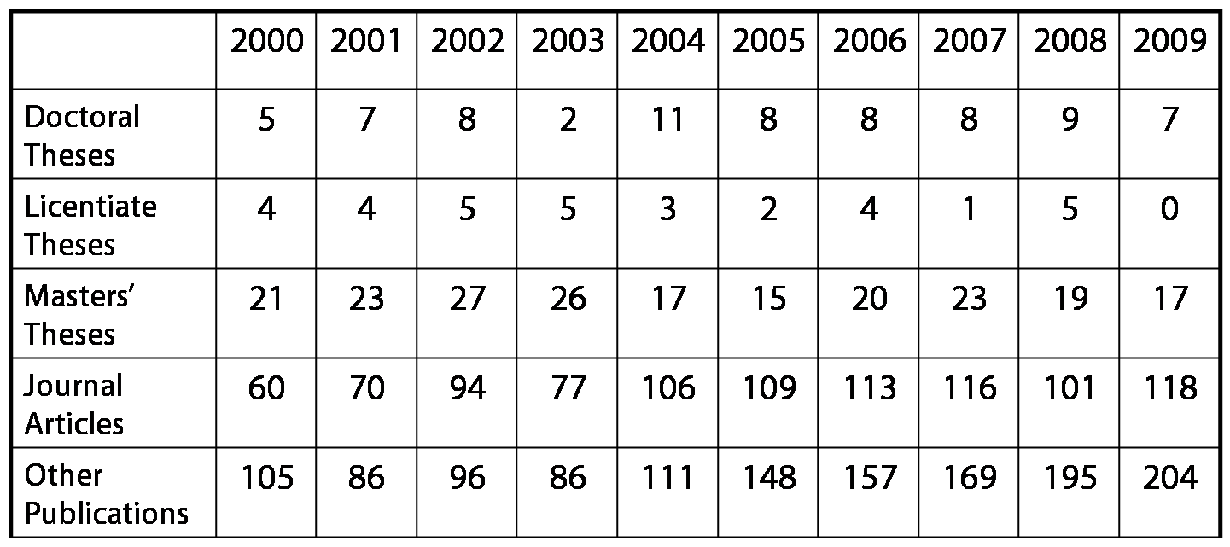

Theses and other publications by the Åbo Akademi Process Chemistry Centre 2000-2009

Besides the technical publications the PCC again published two Newsletters. Our researchers also wrote popular texts in daily newspapers and journals and appeared on several radio and TV programs in the year 2009.

Awards and Recognitions

Niklas Vähä-Savo received the prize for the Best Masters’ Theses in the field of Chemical Recovery in a Kraft Pulp Mill. The prize was granted by the Finnish Recovery Boiler Committee. The title of Niklas´ thesis was “Utveckling och användning av en korttidssond vid mätningar av överbäring i sodapannor” (Development and application of a one-minute probe for measuring carry-over in a recovery boiler, in Swedish), and his supervisors were Patrik Yrjas and Mikko Hupa.

Johan Bobacka and Ari Ivaska were granted a scholarship from the foundation Runar Bäckströms Stiftelse for their invention of a method for precipitation of noble metals from solutions.

Further, Ari Ivaska received the “FIA Honour Award for Science” for his “glorious contribution to advance of modern flow injection analytical method". The award was given by the Japanese Association for Flow Injection Analysis of the Japan Society for Analytical Chemistry.

Doctoral Students

As in previous years, a central part of our research activities is done as part of the doctoral theses works. Altogether 50 PhD thesis projects are actively underway at the Centre. Our doctoral students at the PCC are very international, and their diversity is presented in the graph below. More detailed information of the background of our PhD students is given in the Appendix 1 on page XX of this Annual Report.

At the moment, 41% of the PCC doctoral students are female.

Many of the PhD works are done with support from the national graduate schools. At the moment the PCC is responsible for the coordination of the national Graduate School in Chemical Engineering (GSCE). The GSCE consists of altogether 26 participating laboratories at four universities: Aalto University School of Science and Technology, Lappeenranta University of Technology, the University of Oulu and Åbo Akademi University. In 2009 44 students were participating in the activities of the GSCE, 12 of them from our Centre.

The PCC groups have further participated in the graduate schools of Materials Research (GSMR), Pulp and Paper Science and Technology (PaPSaT), Chemical Sensors and Micro Analytical Systems (CHEMSEM), Environmental Science and Technology (EnSTe), Nanoscience (NGS-NANO), Biomaterial Graduate School (BGS), and the Graduate School for Biomass Refining (BIOREGS).

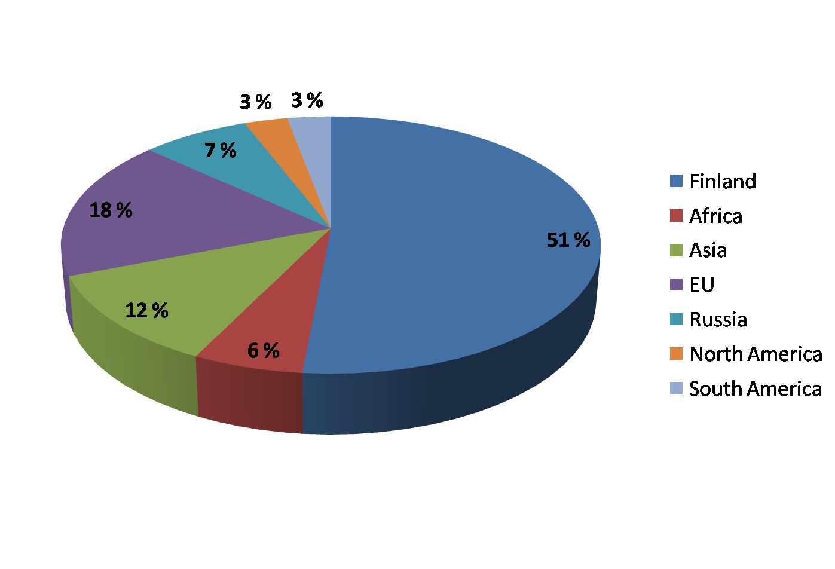
Nationality of the PhD students at PCC 2009-2010. For more detailed information see Appendix 1 on page XX

The Nordic Graduate School in Biofuel Science and Technology is part of the Nordic Energy Research activities funded by the Nordic Council of Ministers. This school is a collaborative effort by Chalmers University of Technology, the Technical University of Denmark, the Norwegian University of Science and Technology and Åbo Akademi University. This school has received funding for the four-year period 2007-2010. The PCC acts as the coordinator for this collaborative School.

Bioraff

For the period 2006-2011 as Centre of Excellence we made a completely new common overall research plan. The new overall title of our research program for the years 2006-2011 is “Sustainable Chemistry in Production of Pulp and Paper, Fuels and Energy, and Functional Materials”. This plan divides our research in nine research areas. In this Annual Report all our research activities are now divided into these nine research areas.

Today there is a great interest towards process concepts which make use of the biomass raw material in an optimum way in the production of pulp and paper, specialty chemicals of various kind, biomass derived fuels and energy. Research topics connected to these concepts, which nowadays are often referred to by the term biorefinery, have already long been in the focus of our Centre.

Our most important project in this area has the title Chemistry in Forest Biorefineries, “Bioraff”. In this project we address a number of aspects in such concepts using tree based feed stocks, forest biorefineries. This project in which we collaborate with several outside groups is the largest PCC project under way and funded by Tekes and ten industrial companies. The partners and Tekes confirmed their support to this project for the next three-year period 2009-2011. The Bioraff project is co-ordinated by Professor Markku Auer and all four groups of the PCC actively participate in the project.

Boards and Task Forces

The PCC is led by an executive board consisting of the four research group leaders, Professors Bjarne Holmbom, Mikko Hupa, Ari Ivaska and Academy Professor Tapio Salmi. Maria Ljung works with the coordination of the PCC and functions as secretary to the board. In 2009 the board met 9 times.

The board was supported by a Scientific Advisory Board (SAB) appointed by the Academy of Finland and an Industrial Advisory Board. In 2009 our Scientific Advisory Board consisted of the Professors Douglas Reeve from the University of Toronto, Jean-Claude Charpentier from CNRS in Lyon and Jiri Janata from the Georgia Institute of Science and Technology in Atlanta. In addition, Professor Johanna Buchert from the VTT represented the Academy of Finland and Jukka Leppälahti represented Tekes, the Finnish Funding Agency for Technology and Innovation in this Board.

In 2009 the Scientific Advisory Board visited the Centre in August in connection with the Annual Seminar of the Centre (August 19-20, 2009).

Our Industrial Advisory Board (IAB) consists of representatives of the key industrial companies co-operating with the Centre. The members of the IAB are listed in Chapter 2 in this Annual Report.

In 2009 the PCC had three lectures in its Distinguished Lecturer Series:

- March 6, 2009: Prof. Robert J. Davis, University of Virginia, Charlottesville, VA, USA: "Catalytic Conversion of Biorenewable Molecules to Fuels and Chemicals"
- June 4, 2009: Prof. Marek Trojanowicz, Department of Chemistry, University of Warsaw, Warsaw, Poland: "Exploiting Artificial Nanostructures in Modern Methods of Chemical Analysis"
- November 19, 2009: Prof. Ernő Lindner, The University of Memphis, Memphis, TN, USA: "Evaluating the Performance Characteristics of a New Device or Method: Method Comparison Studies and Their Pitfalls"

Acknowledgements

As previously, this annual report gives an overview of the activities in 2009-2010 at the Centre. The report has a complete list of the journal articles, theses and other publications produced by the Centre in the calendar year 2009. It also has an activity calendar listing the main events where members of the Centre have contributed or participated during that year.

The report is edited by an editorial team consisting of Maria Ljung, Anders Brink, Rose-Marie Latonen, Päivi Mäki-Arvela and Anna Sundberg. The layout was done by Paul Söderholm.

Again, we want to sincerely thank all our collaborating partners in Finland and all over the world for the inspiring work together.

On behalf of the Board of the Åbo Akademi Process Chemistry Centre,

Mikko Hupa
Chairman

